Fly Synapses
First rule of Synapse club:
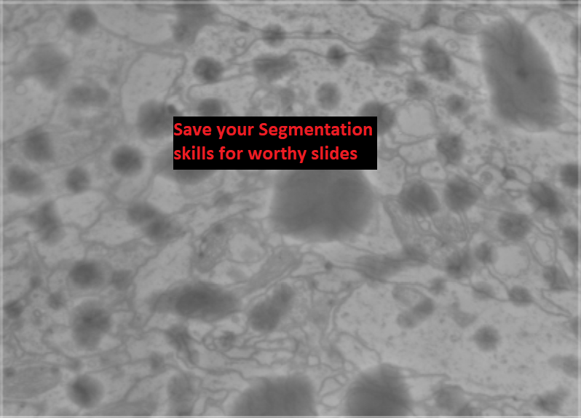

Second rule of Synapse club:
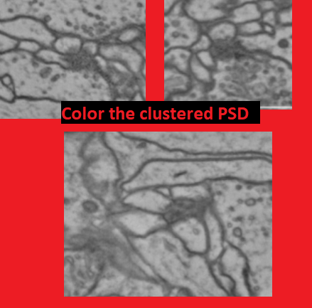
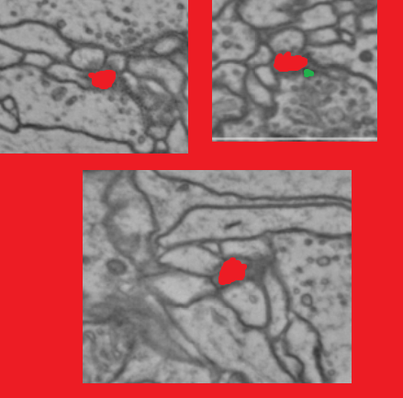

Third Rule of Synapse Club:
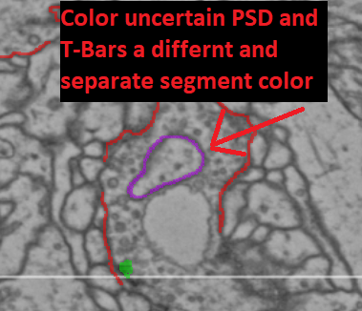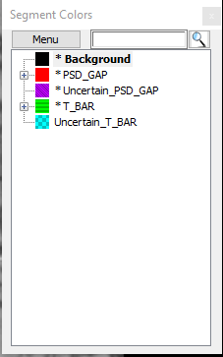

Fourth Rule of Synapse Club:
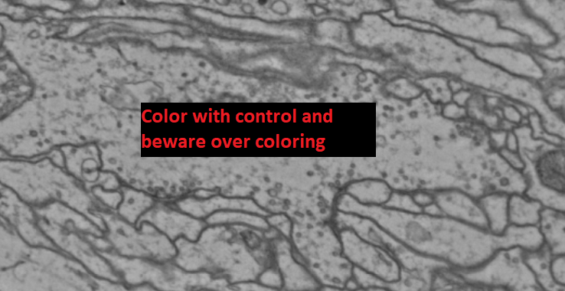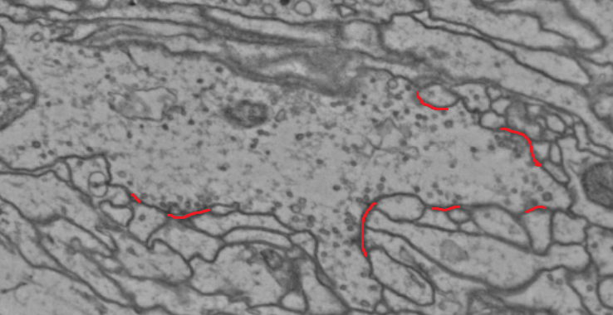
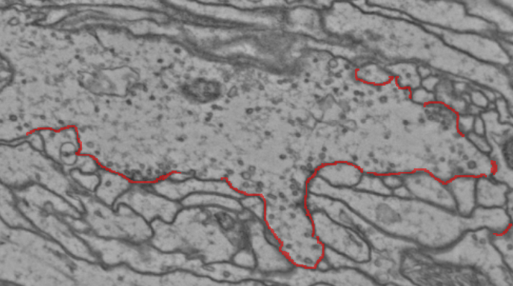
(No control!!!!! ^^^^^^^^^^^^^^^^^^^^^^^^^^^^^^^^^^^^^^^^^^^^^^)
Fifth Rule of Synapse Club:
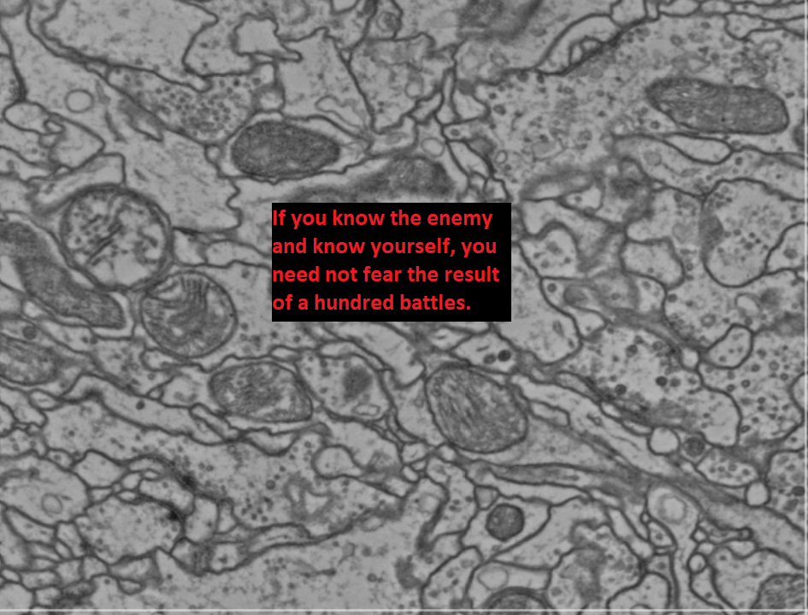

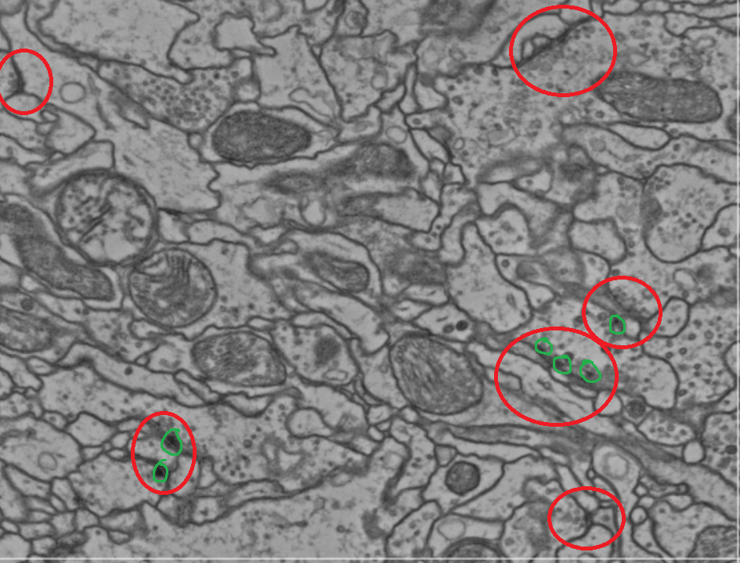
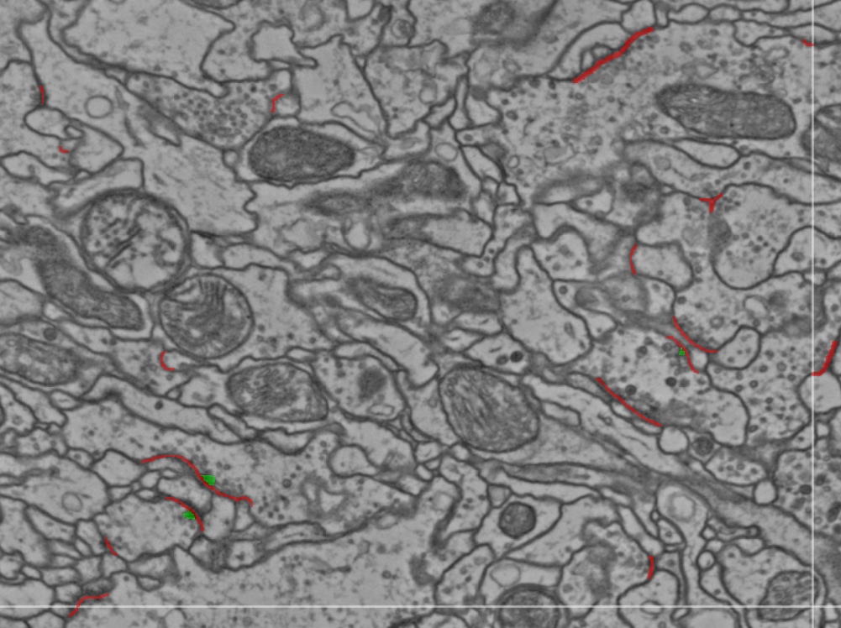

- Clusters aka rosettes
- Axon to axon synapses
- Open cleft thing
- Color uncertain segments different segment color
- Same with T_Bars
- Fused vesicles
- Things you’re unsure of make a note and report about it once you’re finished (Slice number and coordinates - if not obvious)
- When reviewing keep an eye out for ‘over coloring’ and missed, tougher, synapses
- A good method to find synapses is to find an axon and look for it’s vesicles
- Some axons have sparse vesicles and some have loads of dense vesicles. In the sparse axons keep a keen eye out for little clusters of 1-6 vesicles usually near its boundaries.
- Sometimes T Bars are really short or just dots, sometimes they are longer or ‘travel’.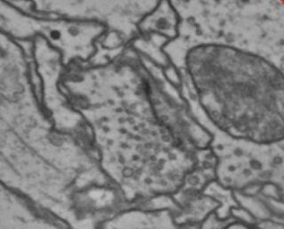Longer T Bar
- 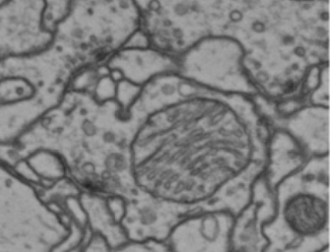Short T_Bar

- 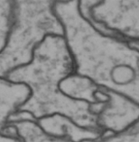 Sparse Vesicles here
- 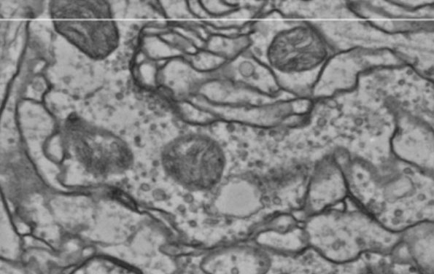Dense Vesicles here

How to tell the difference between a PSD and the ‘shadow’ of a surfacing neuron

The PSD of a synapse and the shadow of a surfacing neuron can often look similar and can be tricky to tell apart. In the example below, we see the surfacing of a dendrite from below an axon. Compare the darkened area in this interaction to some of the PSD’s of the examples of synapses found elsewhere in this document. Notice that there are some key differences between these two scenarios.
- In a synapse, the darkened area is located in the dendrite/postsynaptic body rather than the axon/presynaptic body. In the example below, there are two slices with a darkened area; one resides in the axonal body and one in the dendritic body.
- Synapses have 4 indicators, one of which is mandatory. Of the following 4, you only need the presence of the primary indicator, highlighted below in red, and 2 out of 3 of the others. Notice that in the example below, the encircled area lacks a dense cluster of vesicles, a synaptic cleft and a T-bar.
  - Dense cluster of vesicles
  - PSD
  - Synaptic cleft
  - T-bar
- Lacking the primary indicator, and lacking at least two out of three of the secondary indicators, an area such as the example below, should not be annotated.

